Randunu Bandara - 806

(Group A)

Project Management

19th March to 30th June

Progress Report

Team Members

1. Randunu Bandara.
2. Thushan Devinda.
3. Bathiya Lakruwan.
4. Anduradha Kandewaththe.

Scrum Backlog

Sprint 1

|  |
| --- |
| Tasks to do |
| 1. Preparing the project proposal |
| 1. Upload the re-worked Project Proposal |
| 1. Preparing the SRS |
| 1. Preparing the Interim Report |
| 1. Register |
| 1. Log in |
| 1. log out |
| 1. Home page |
| 1. logo design and suggesting a name for the Application |
| 1. About page |
| 1. Weather page and about crop |
| 1. Farmer Registration |
| 1. Customer Registration |
| 1. Transport owner Registration |
| 1. Consultant Registration |
| 1. Selling Items page |
| 1. Connect Farmer and consultants to a forum |
| 1. Connecting Selling items page with farmer |
| 1. Today’s market price page |
| 1. E-Banking feature |
| 1. Tracking farmers location |

Sprint 2

Sprint 3

To Do list

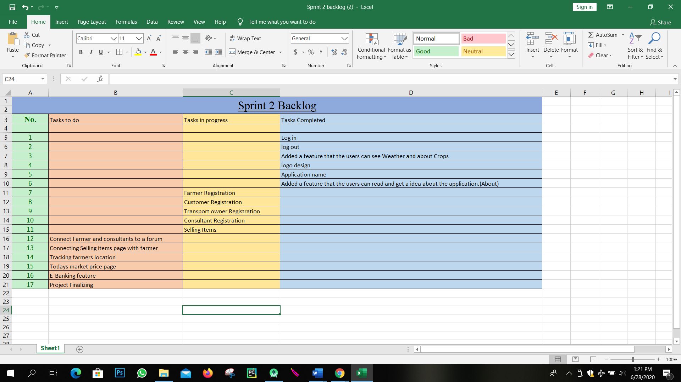This is the to do list for our project (28th June 2020)

Meetings.

We use WhatsApp and also Google meet to held our meetings. And also, for the urgent reasons we get WhatsApp calls and we message through a WhatsApp group.

Meeting 2.

Meeting 1.

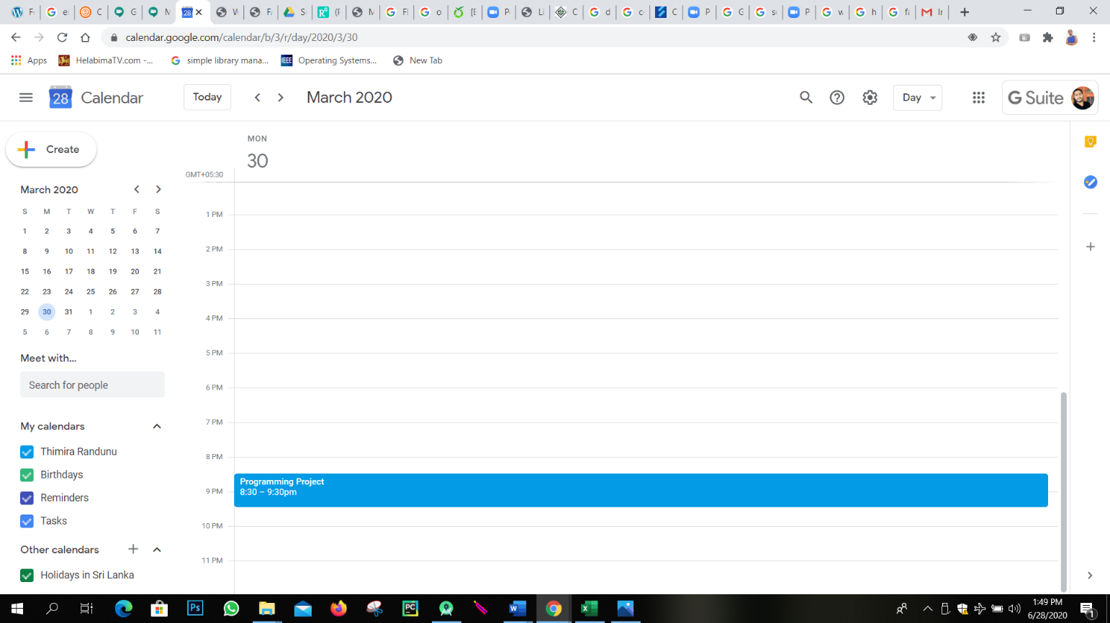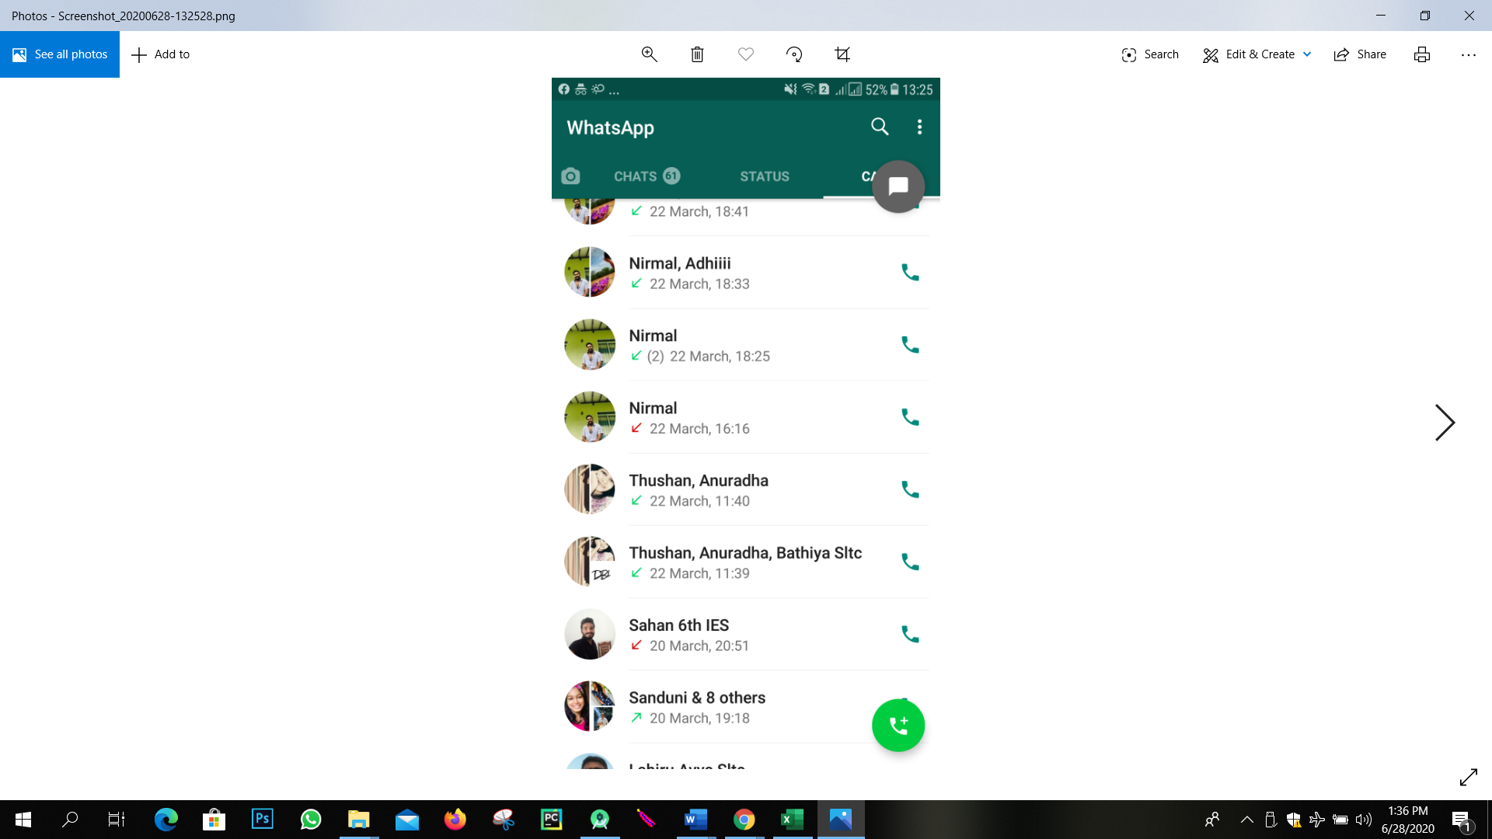

Meeting 3.

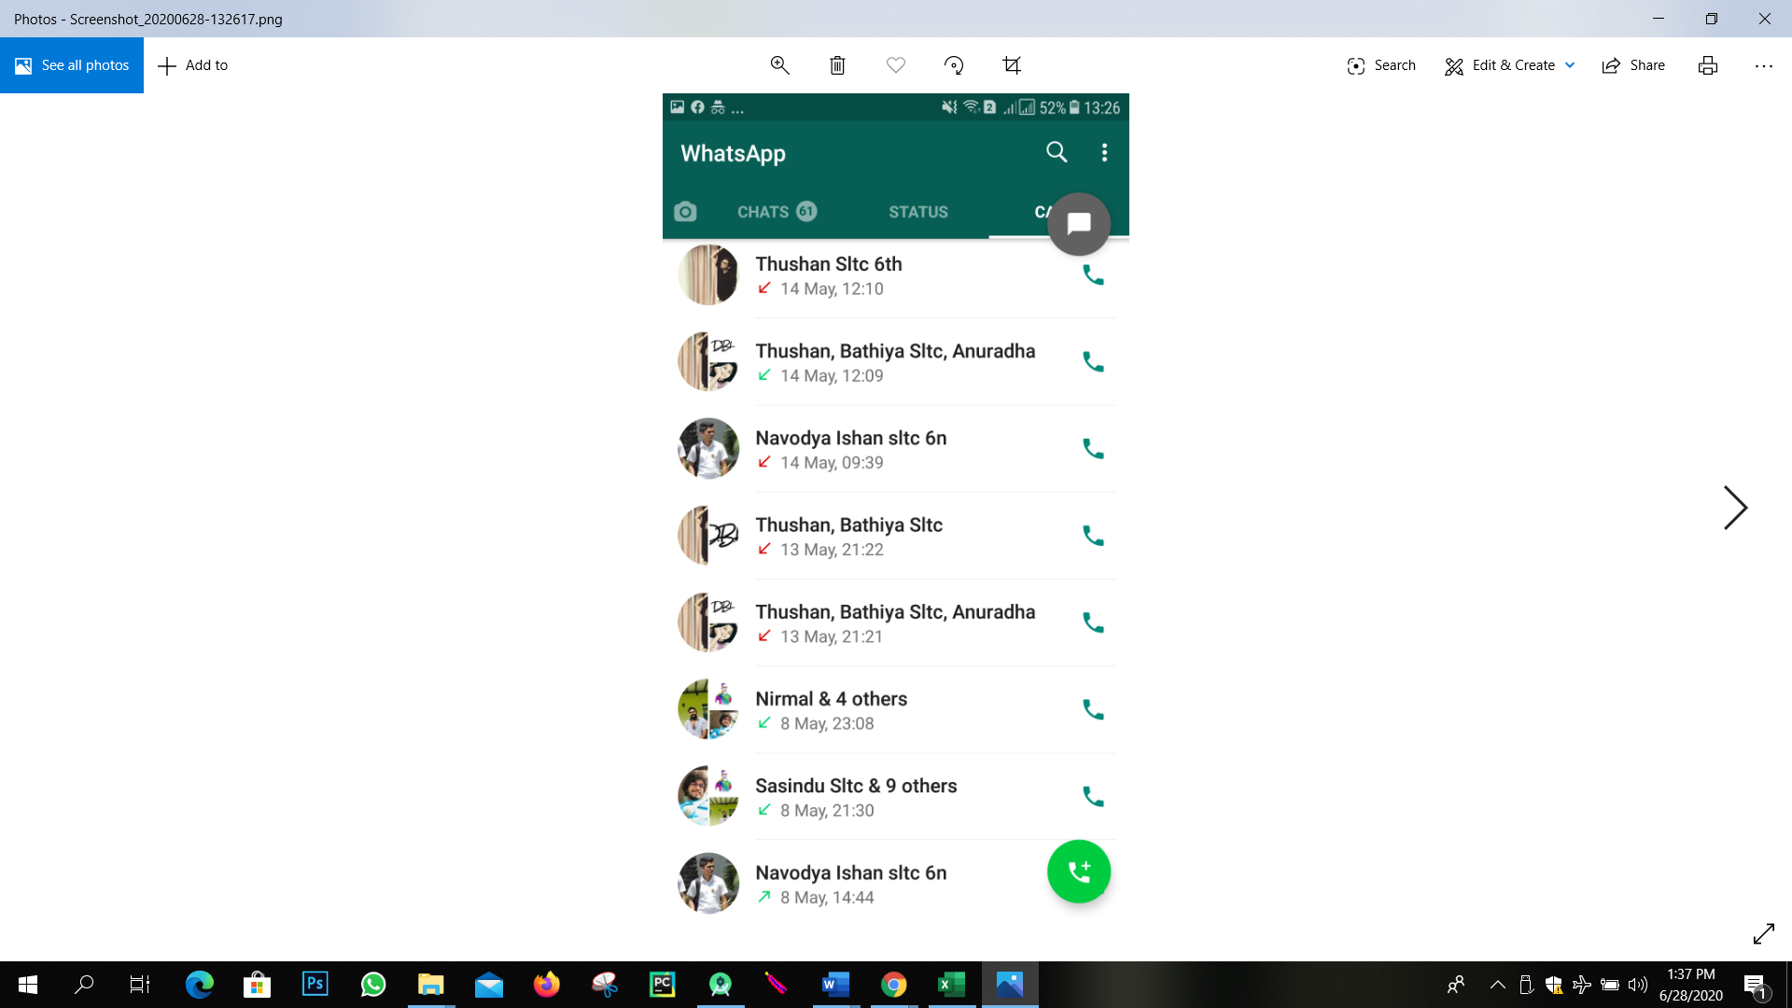

Meeting 5.

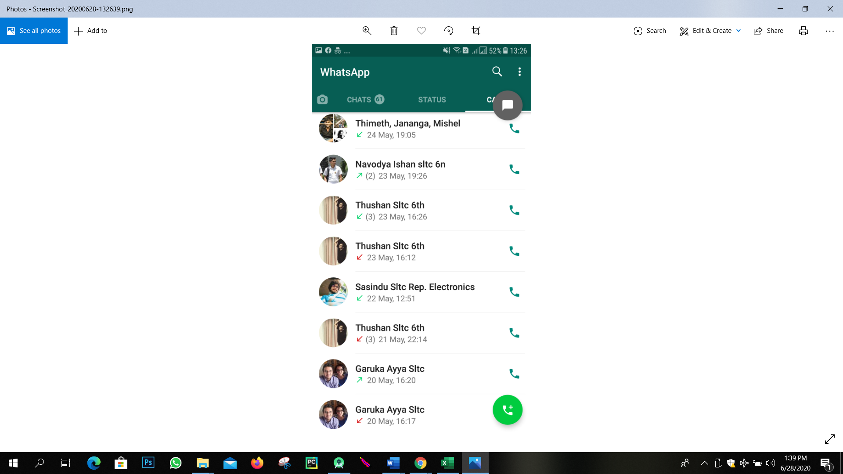

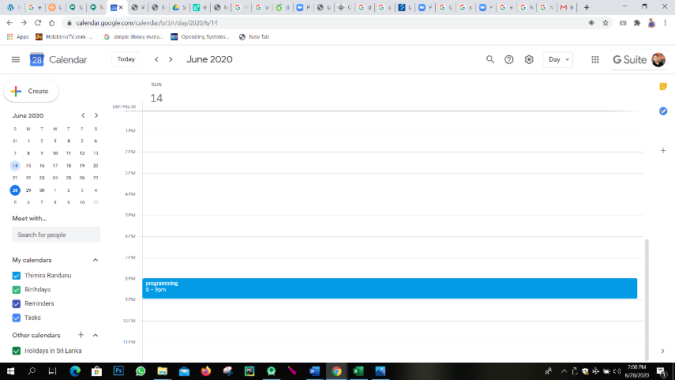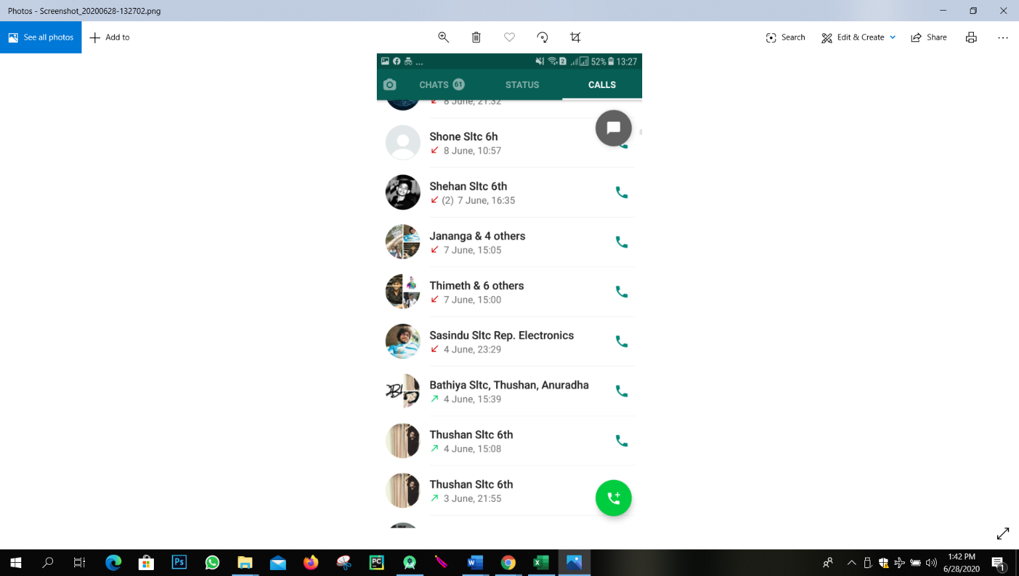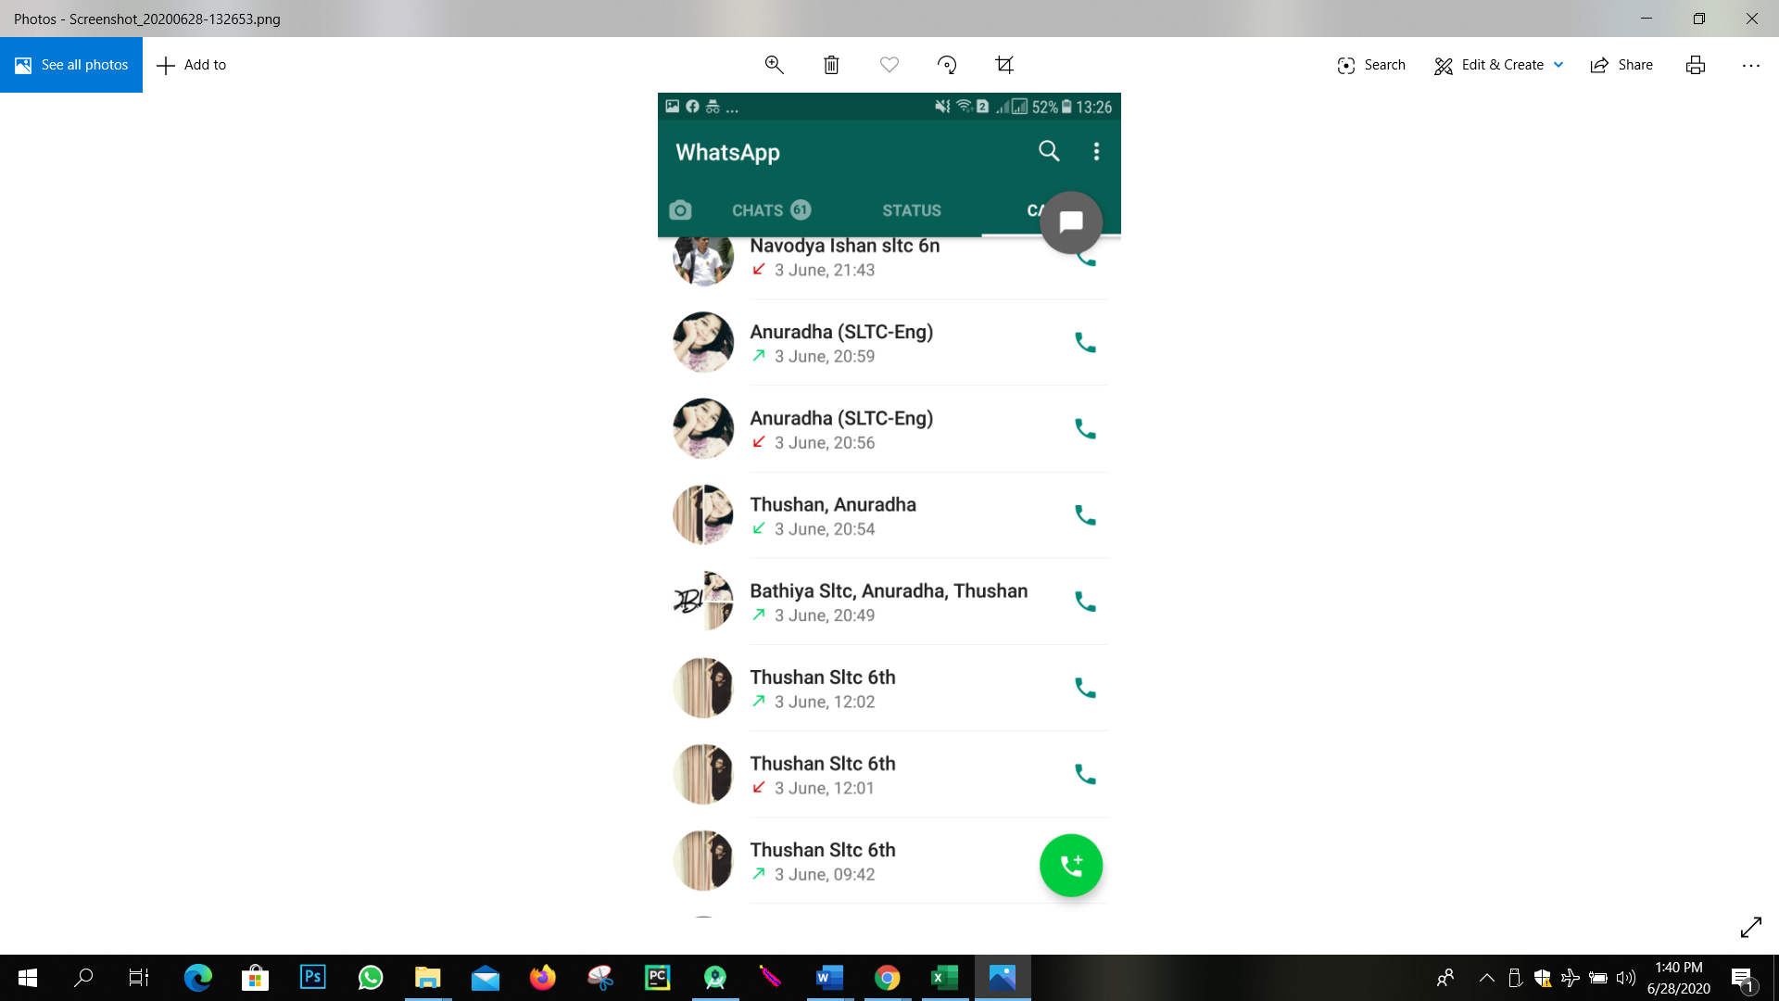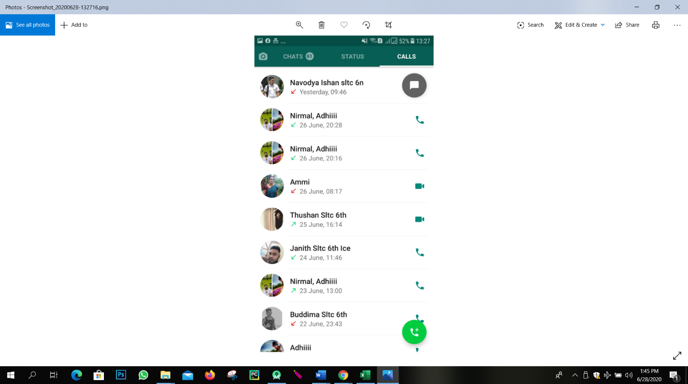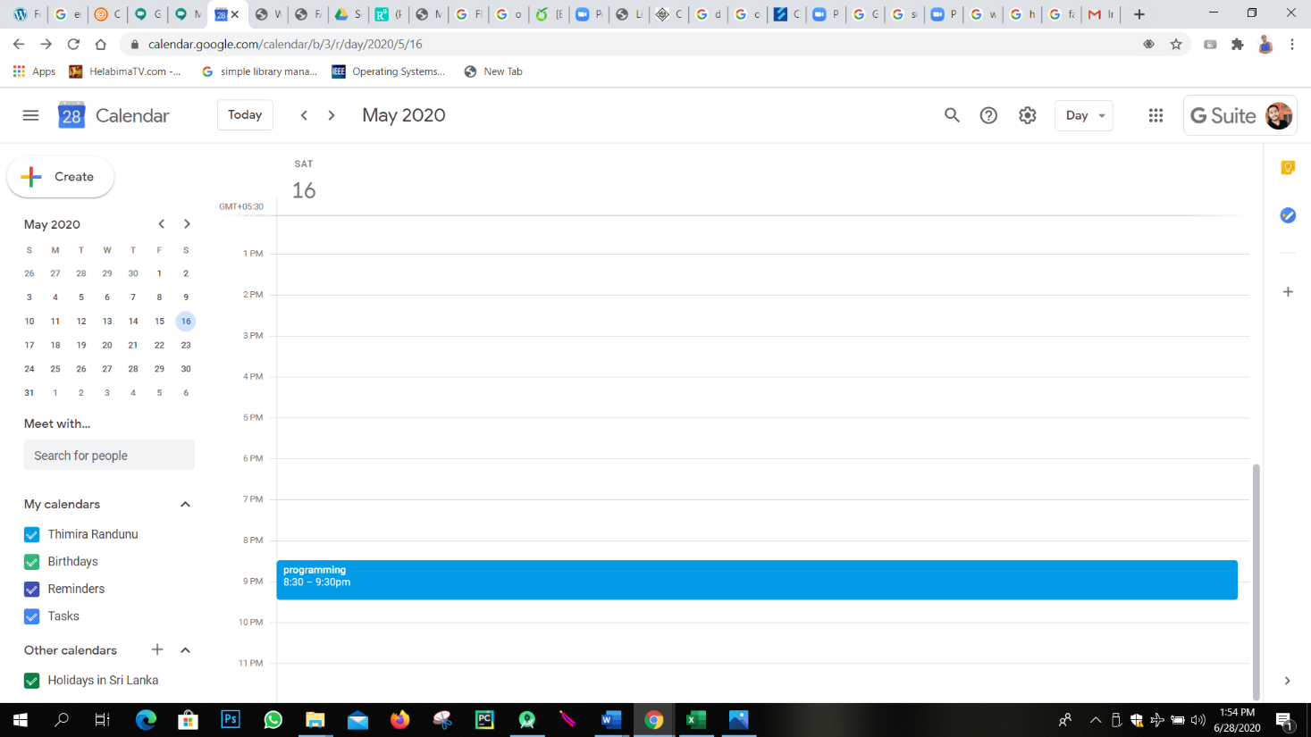

Meeting 7.

Meeting 6.

Meeting 8.

Meeting 4.

The agenda is same for all the meetings.

First, we spoke about the to-do list. And we assign the team members to do that tasks.

Meeting Attendance.

|  |  |  |  |  |
| --- | --- | --- | --- | --- |
| Date | Randunu | Thushan | Bathiya | Anuradha |
| 22/03/2020 | P | P | P | P |
| 30/03/2020 | P | P | P | P |
| 14/05/2020 | P | P | P | P |
| 16/05/2020 | P | P | P | P |
| 23/05/2020 | P | P | AR | AR |
| 03/06/2020 | P | P | P | P |
| 04/06/2020 | P | P | P | P |
| 25/06/2020 | P | P | AR | AR |

P-Present AR-Absent (Apology Received)

Risks.

* Power Cuts.
* unfavorable weather.
* Working with new programming languages
* Connection problems.
* Deadlines.
* Working with Another Person's Code
* Don’t know new terms.

As this is a group project each member in the group have a task to do by himself. If one member was unable to do his task on time others in the group have to face lot of problems.

1. Power cuts.

When we are working with our project, some days, for some areas in the county there were power cuts. So, the group member who is suffering with the power cut could not able do his task on time. So, the project gets stuck due to that reason. To get overcome from that other group members did that person’s tasks too.

1. Unfavorable weather

This is another problem that we faced when are doing our project. Due to heavy rains, thundering, lightning, flood we were unable to work with our laptops.

1. Working with new programming languages.

For our group members this is the first experience of working with php and handling a database. So, it become a big challenge for us. We have to watch lot of you tube videos and we also read lot of articles about those new programming languages to solve our problems and to continue the project.

1. Connection Problems.

If someone is having a connection problem at a time that we going to have a meeting, it is not possible to have that meeting. So, we have to postpone that meeting to another day. But if we postponed that meeting all the other works of the project also getting postpone. If all the works get postponed, we are unable to submit the things on time. So, sometimes we had to have the same meeting twice.

1. Working with Another Person's Code

If someone is having a power cut or he is suffering with a bad weather condition and there is also a deadline to submit our project, we somehow need to complete the project. In that kind of a situation, we need do continue that person’s code too.

## Presentation of final artefact

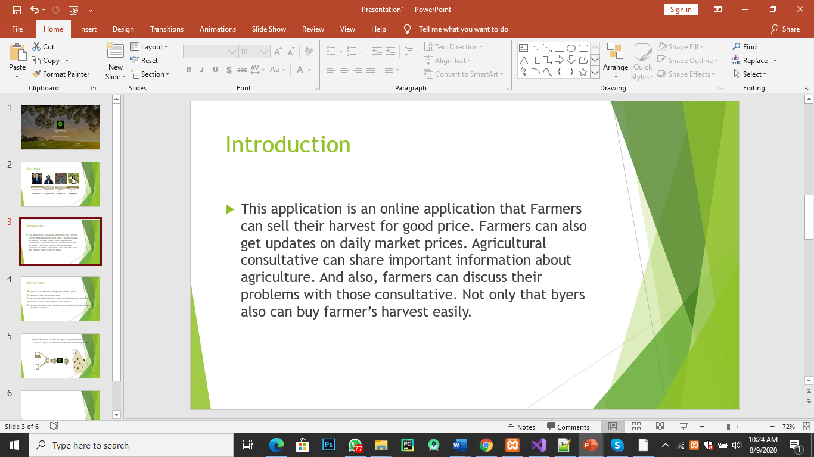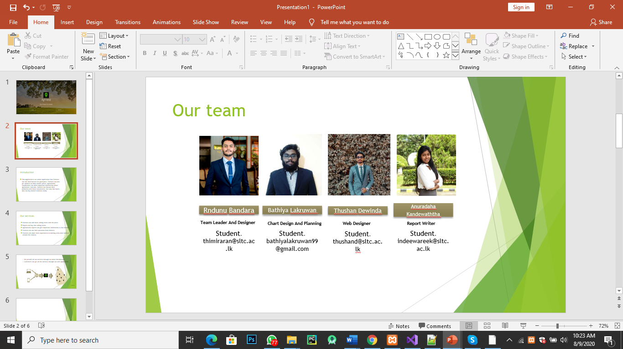

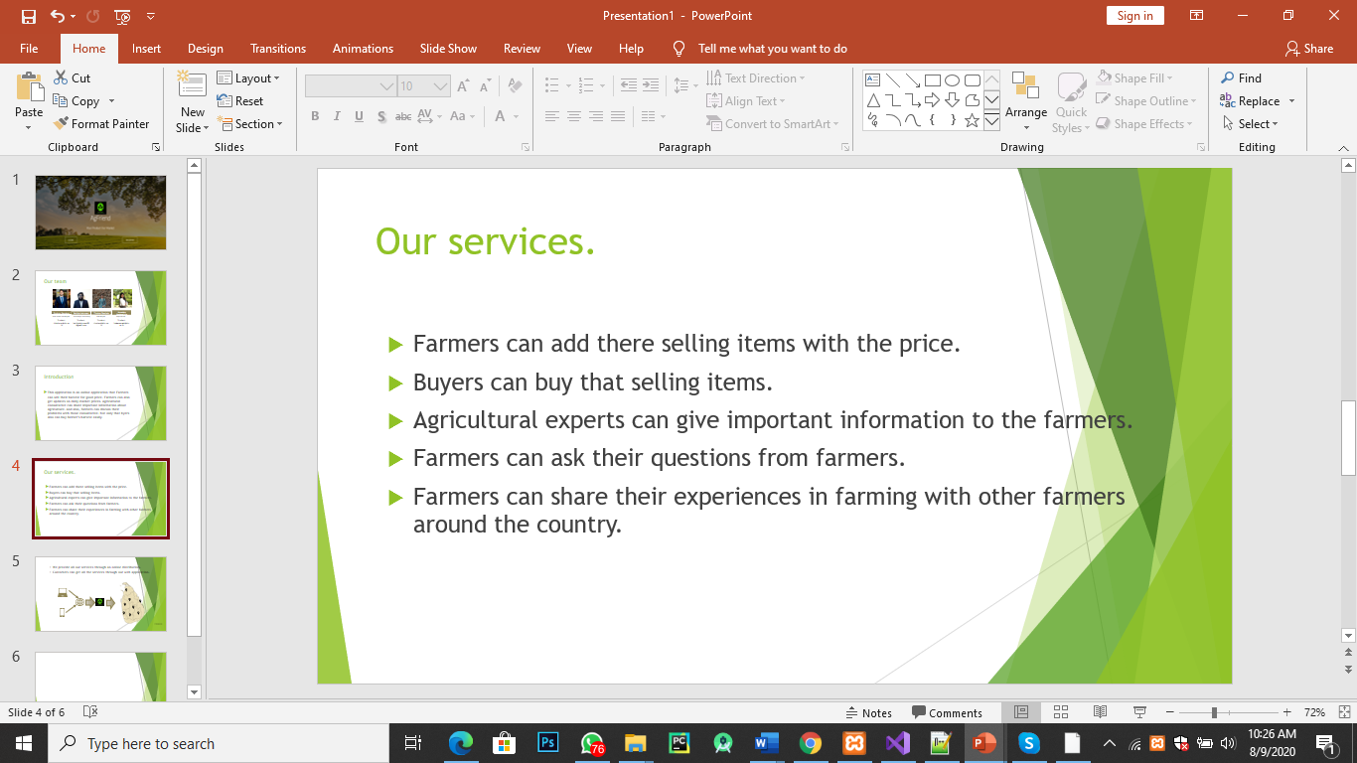

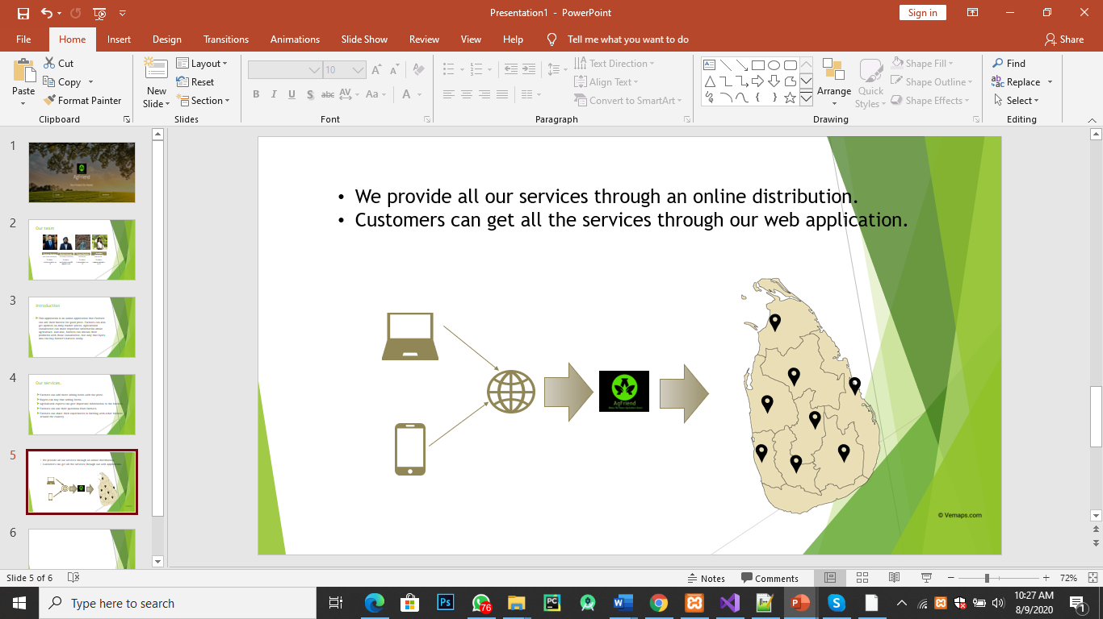

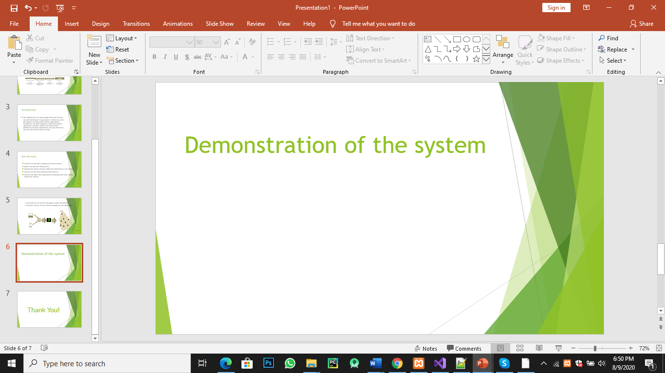

## Meeting for the client.

We planned to have an online meeting. At the beginning we will give a brief explanation on what are the problems that we found there in the agricultural field in Sri Lanka. Then we will give a brief introduction about our system. Then we will present what are the features and the services that we are giving to the users from our system. Then we planned to give a demonstration of our system. After the demonstration there is a session that the clients can ask their questions from us.

Role Allocation.

Presenting the presentation:

1. Randunu Bandara.
2. Bathiya Lakruwan.
3. Anduradha Kandewaththe.

Demonstration:

1. Thushan Devinda.

Giving Answers to the clients:

1. Randunu Bandara.
2. Thushan Devinda.
3. Bathiya Lakruwan.
4. Anduradha Kandewaththe.